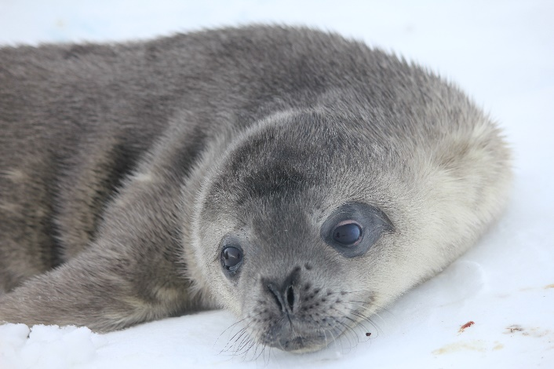  NMFS 21006-01 | Mr. Goodbar  Date of Birth: October 20, 2019 (approximate)  Age: 1 Week Old  Straight Length nose to tail: 121 cm  Curve Length nose to tail: 138 cm  Mass: 36.5 kg  Blubber Depth Dorsal Sternum: 1.42 cm  Fun Fact: When the pups are born, they have a layer of baby fur, called lanugo, and they have almost no blubber.
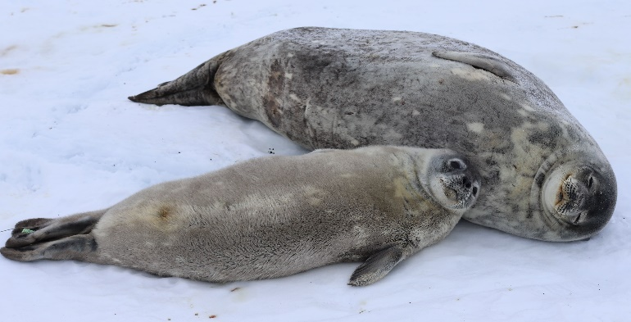  NMFS 21006-01 | Mr. Goodbar  Age: 3 Weeks Old  Straight Length nose to tail: 134 cm  Curve Length nose to tail: 154 cm  Mass: 65 kg  Blubber Depth Dorsal Sternum: 2.4cm  Fun Fact: Mr. Goodbar was often found resting in the same position as his mom.
NMFS 21006-01  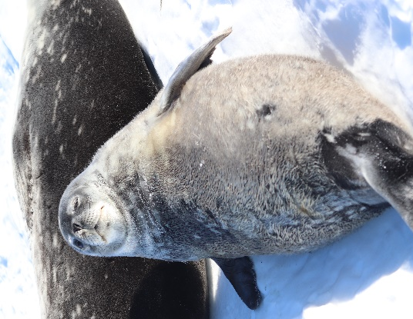 | Mr. Goodbar  Age: 5 Weeks Old  Straight Length nose to tail: 147 cm  Curve Length nose to tail: 159 cm  Mass: 88 kg  Blubber Depth Dorsal Sternum: 3.15 cm  Fun Fact: Weddell seals can dive up 2,300 feet (700 meters) deep. That is about 59 big yellow school buses long!
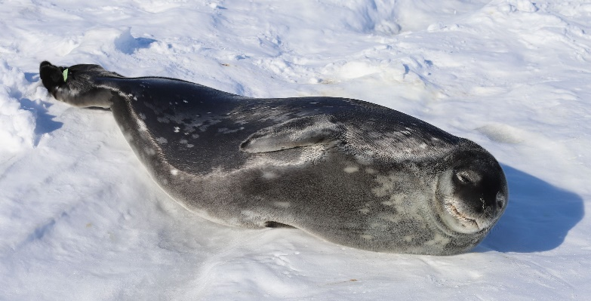  NMFS 21006-01 | Mr. Goodbar  Age: 7 Weeks Old  Straight Length nose to tail: 152 cm  Curve Length nose to tail: 168 cm  Mass: 102.5 kg  Blubber Depth Dorsal Sternum: 3.5 cm  Fun Fact: About 40% of an adult Weddell seal’s mass will be blubber. This blubber layer is around 5.08 cm.

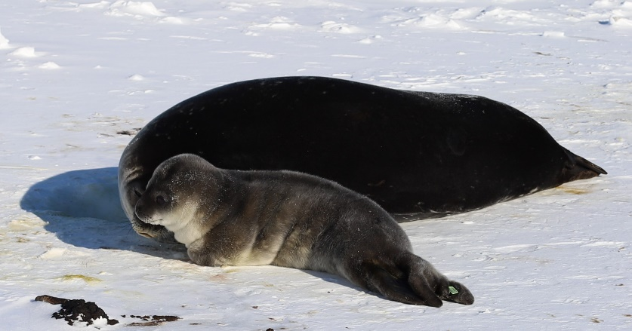  NMFS 21006-01 | Caramello  Date of Birth: October 13, 2019 (approximate)  Age: 1 Week Old  Straight Length nose to tail: 127 cm  Curve Length nose to tail: 140 cm  Mass: 51 kg  Blubber Depth Dorsal Sternum: 1.49 cm  Fun Fact: Weddell Seal pups shiver to help stay warm!
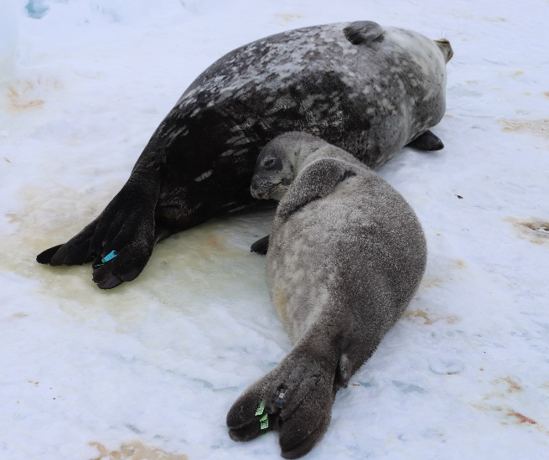  NMFS 21006-01 | Caramello  Age: 3 Weeks Old  Straight Length nose to tail: 136 cm  Curve Length nose to tail: 153 cm  Mass: 65 kg  Blubber Depth Dorsal Sternum: 2.95 cm  Fun Fact: Caramello got his name because he was a mellow little pup. He stuck close to his mom and seemed to have an easygoing personality.
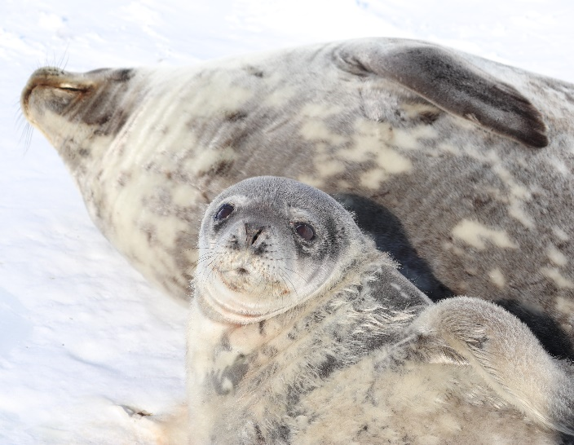  NMFS 21006-01 | Caramello  Age: 5 Weeks Old  Straight Length nose to tail: 142 cm  Curve Length nose to tail: 163 cm  Mass: 85.5 kg  Blubber Depth Dorsal Sternum: 2.72 cm  Fun Fact: Weddell seals can stay underwater for up to 80 minutes. They could hypothetically watch the entire original Disney movie, The Jungle Book, while underwater, without taking a breath!
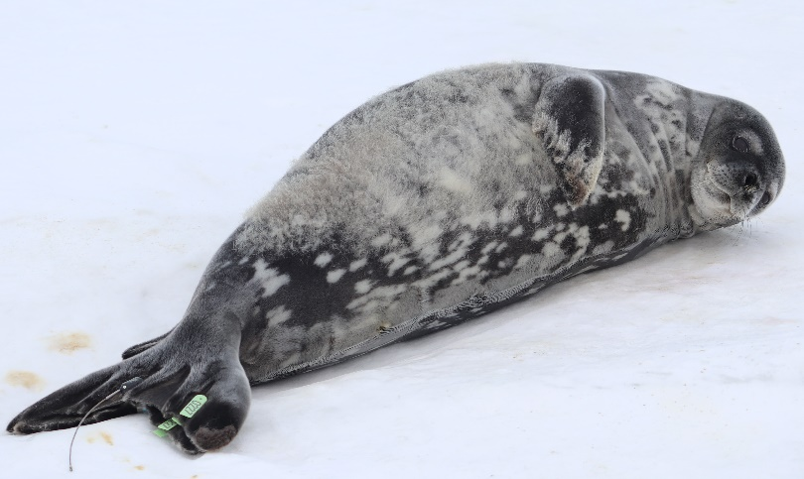  NMFS 21006-01 | Caramello  Age: 7 Weeks Old  Straight Length nose to tail: 153 cm  Curve Length nose to tail: 158 cm  Mass: 83 kg  Blubber Depth Dorsal Sternum: 3.01 cm  Fun Fact: How to tell seals and sea lions apart:  Seals have an ear hole and sea lions have an ear with a flap. Seals scoot on their belly when moving across land and sea lions use their flippers to “walk”.

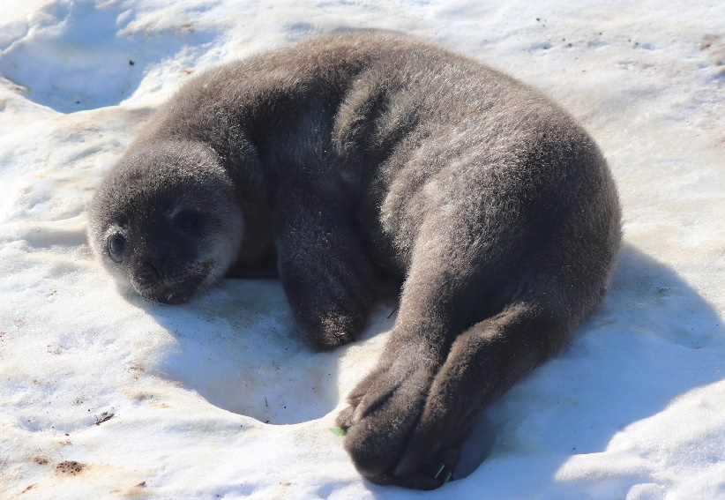  NMFS 21006-01 | Smartie  Date of Birth: October 26, 2019 (approximate)  Age: 1 Week Old  Straight Length nose to tail: 121 cm  Curve Length nose to tail: 136 cm  Mass: 41 kg  Blubber Depth Dorsal Sternum: 2.07 cm  Fun Fact: Weddell seal pups are usually born starting the second week of October, when the average temperature is around -19° Celsius (-2.2 ° Fahrenheit) and the average wind speed is 11 mph. However, the conditions can be much colder and wind speed can get much higher.
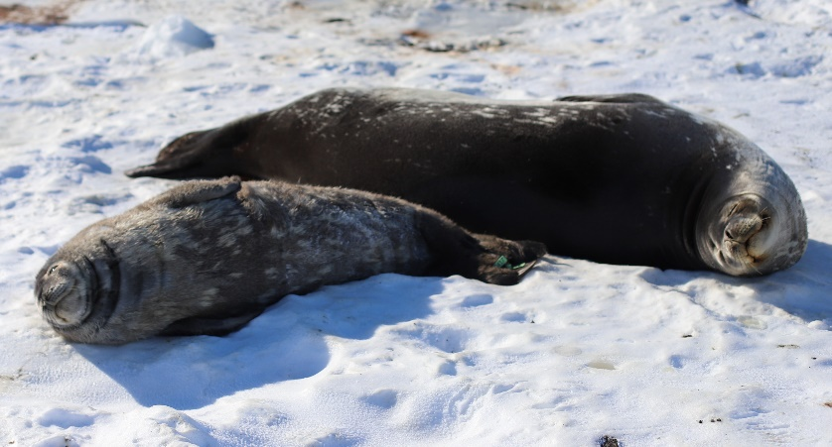  NMFS 21006-01 | Smartie  Age: 3 Weeks Old  Straight Length nose to tail: 136 cm  Curve Length nose to tail: 152 cm  Mass: 79 kg  Blubber Depth Dorsal Sternum: 2.57 cm  Fun Fact: Smartie was always by his mom’s side. She could get him to go in the water, but it took a while for him to be willing to start his diving lessons.
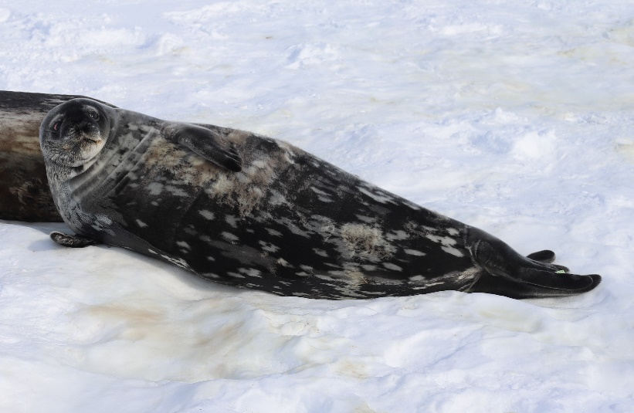  NMFS 21006-01 | Smartie  Age: 5 Weeks Old  Straight Length nose to tail: 145 cm  Curve Length nose to tail: 165 cm  Mass: 102 kg  Blubber Depth Dorsal Sternum: 3.77 cm  Fun Fact: Weddell seals see in low light conditions below the sea ice due to a special structure in their eyes called the tapetum lucidum Have you ever seen your pet dog or cat in a dim room, and it seemed like their eyes were glowing? This glow is caused by their tapetum lucidum eye layer.
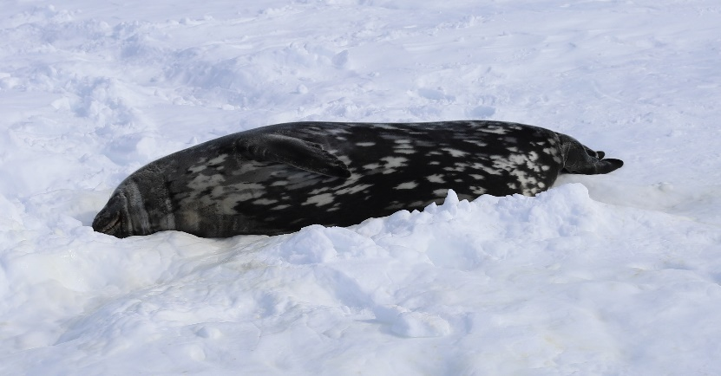  NMFS 21006-01 | Smartie  Age: 7 Weeks Old  Straight Length nose to tail: 155 cm  Curve Length nose to tail: 165 cm  Mass: 107.5 kg  Blubber Depth Dorsal Sternum: 3.4 cm  Fun Fact: Weddell seals favorite food is fish, especially Antarctic cod and Antarctic silverfish. They also eat squid, octopus, and crustaceans like krill or prawns.
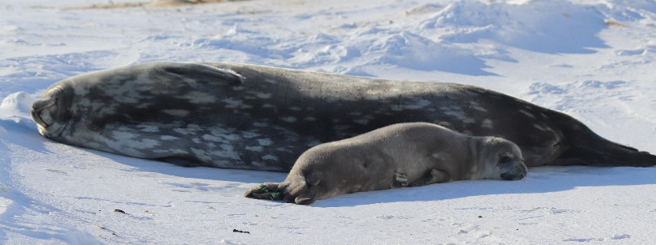  NMFS 21006-01 | Charleston Chew  Date of Birth: October 17, 2019 (approximate)  Age: 1 Week Old  Straight Length nose to tail: 126 cm  Curve Length nose to tail: 141 cm  Mass: 42.5 kg  Blubber Depth Dorsal Sternum: 2.2 cm  Fun Fact: Weddell seals are unusual because they learn how to swim from their moms. Most seals learn how to swim and dive entirely on their own, with no help from mom.
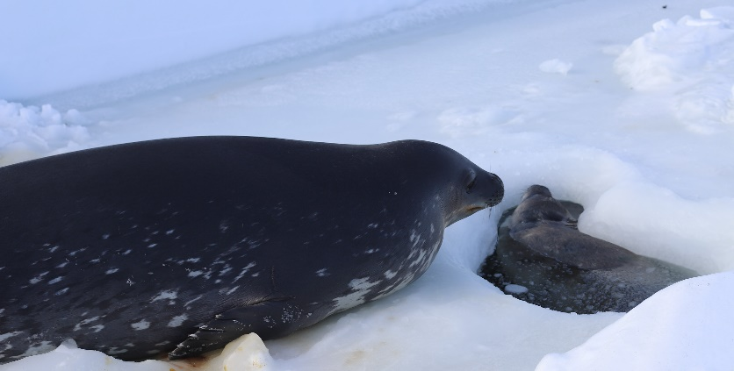  NMFS 21006-01 | Charleston Chew  Age: 3 Weeks Old  Straight Length nose to tail: 139 cm  Curve Length nose to tail: 150 cm  Mass: 66 kg  Blubber Depth Dorsal Sternum: 2.75 cm  Fun Fact: Charleston Chew was feisty pup who was quick to snap at nearby animals, including other pups and even his mom!
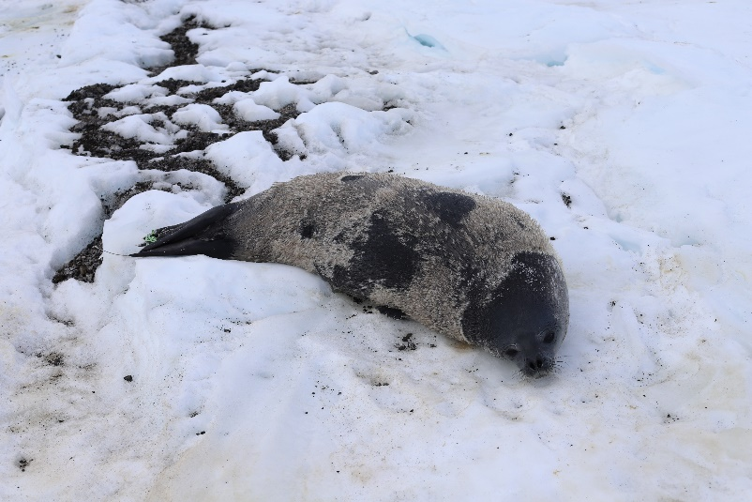  NMFS 21006-01 | Charleston Chew  Age: 5 Weeks Old  Straight Length nose to tail: 148 cm  Curve Length nose to tail: 167 cm  Mass: 96.5 kg  Blubber Depth Dorsal Sternum: 3.18 cm  Fun Fact: Weddell seal whiskers help them to detect water disturbances caused by their prey so that they are able to find food, even in complete darkness.
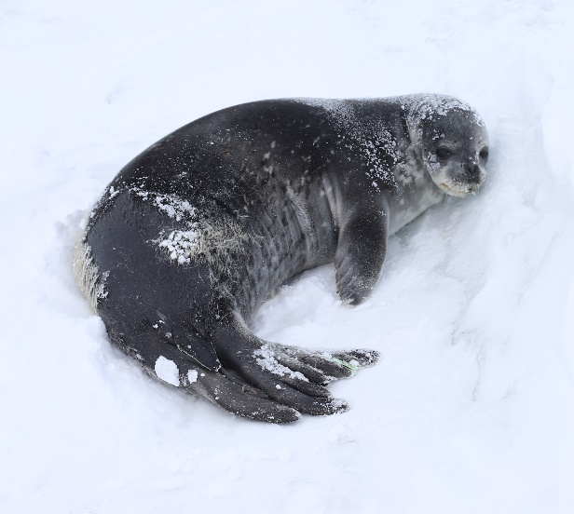  NMFS 21006-01 | Charleston Chew  Age: 7 Weeks Old  Straight Length nose to tail: 150 cm  Curve Length nose to tail: 169 cm  Mass: 101.5 kg  Blubber Depth Dorsal Sternum: 3.79 cm  Fun Fact: Weddell seals were named for Sir James Weddell, a British sealing captain in the 1820s.
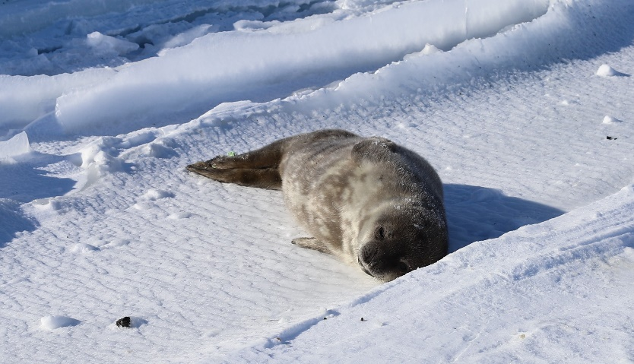  NMFS 21006-01 | Sweetart  Date of Birth: October 18, 2019 (approximate)  Age: 1 Week Old  Straight Length nose to tail: 127 cm  Curve Length nose to tail: 137 cm  Mass: 43.5 kg  Blubber Depth Dorsal Sternum: 1.65 cm  Fun Fact: Weddell seals have their pups on the fast ice because it keeps them safe from their primary predator, killer whales. Because they have no land predators, they are not afraid of humans.
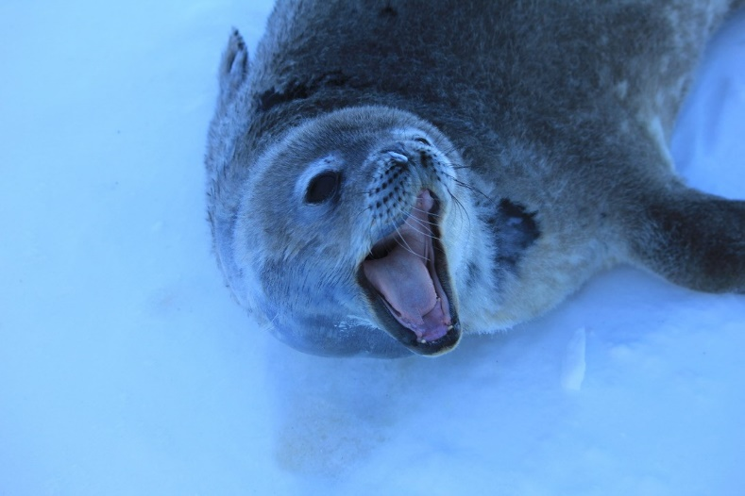  NMFS 21006-01 | Sweetart  Age: 3 Weeks Old  Straight Length nose to tail: 139 cm  Curve Length nose to tail: 155 cm  Mass: 64.5 kg  Blubber Depth Dorsal Sternum: 2.53 cm  Fun Fact: Sweetart had both a lively and a sweet side. She liked to stay tucked behind the snow drifts and sea ice pressure ridges.
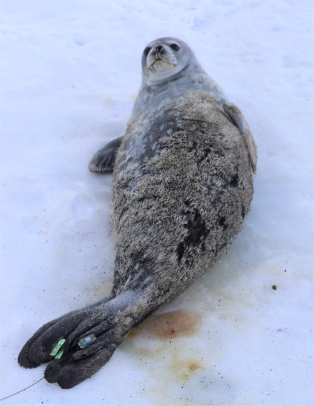  NMFS 21006-01 | Sweetart  Age: 5 Weeks Old  Straight Length nose to tail: 141 cm  Curve Length nose to tail: 158 cm  Mass: 74.5 kg  Blubber Depth Dorsal Sternum: 2.75 cm  Fun Fact: Weddell seals exhale before they dive under water and collapse their lungs. They store oxygen in their blood and muscles to help them make long dives.
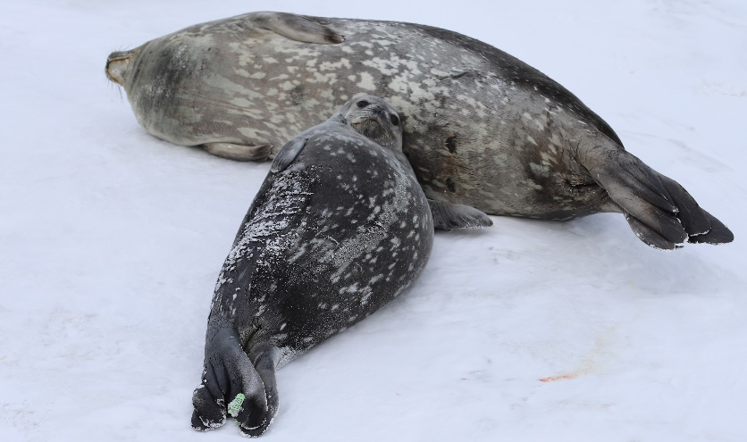  NMFS 21006-01 | Sweetart  Age: 7 Weeks Old  Straight Length nose to tail: 147 cm  Curve Length nose to tail: 169 cm  Mass: 90 kg  Blubber Depth Dorsal Sternum: 3.01 cm  Fun Fact: Weddell seals can have seal lice! The seal lice are not zoonotic, meaning they don't infest people. The team combed through the pups’ fur to collect samples of the lice to study further.

